

FACULTY OF TECHNOLOGY AND ENGINEERING
DEVANG PATEL INSTITUE OF ADVANCE TECHNOLOGY
AND RESEARCH

DEPARTMENT OF INFORMATION TECHNOLOGY

A.Y. 2026-27 Semester-3

LAB MANUAL

CSUC201 Fundamentals of Data Structures and Algorithms



Practical-7

Practical AIM:
To implement queue using array and linked list, and apply queue-based logic to number generation, and structure simulation problems.

7.1

Problem Defination:
A government office has a token counter that issues tokens to visitors. The counter can hold at most n tokens at a time. New visitors join from one end and are served from the other end in the order they arrived. If the counter is full, no new token can be issued, and if it is empty, no one can be served. Given a sequence of join and serve operations, implement this fixed-capacity token system and print the current front token after each operation. Report an error if an operation cannot be performed. Describe how your solution tracks the front and rear of the queue. What happens to your front and rear pointers over time as join and serve operations keep happening, and does your solution handle the case where space appears to run out even though slots have been freed?

Output:
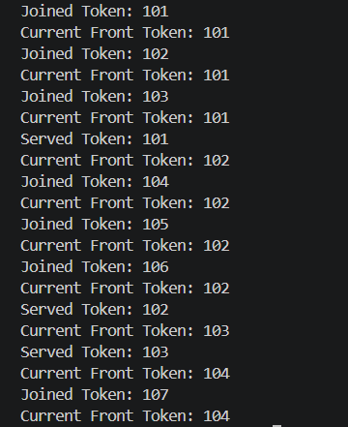
Difficulty Faced:
The main difficulty was managing the front and rear pointers correctly during join and serve operations, especially when the queue became full or empty.
Solution:
I used front to track the first token and rear to track the last token. The pointers are updated after every join and serve operation. Overflow and underflow conditions are checked before performing an operation.
Outcome:
The fixed-capacity queue was successfully implemented with proper front and rear tracking. The solution also handles freed spaces correctly using a circular queue, preventing unused slots from causing false overflow.

7.2

Problem Defination:
A hospital emergency ward receives patients continuously and attends to them strictly in the order they arrived, with no upper limit on how many can be waiting at once. New patients are added at the back and the doctor always attends to the patient at the front. Given a sequence of arrive and attend operations, implement this unlimited patient queue and print the current front patient after each operation. Describe how your solution differs from Problem 1 in how it manages capacity. What happens in your solution when the attend operation is called on an empty ward with no patients waiting?
Output:
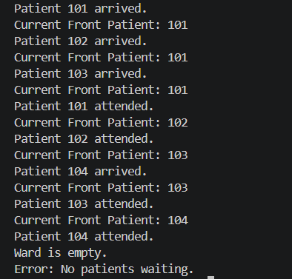
Difficulty Faced:
The main difficulty was managing the queue dynamically and correctly handling the empty queue condition.
Solution:
I used a linked-list-based queue where patients are added at the rear and removed from the front. Before attending a patient, the program checks whether the queue is empty.
Outcome:
The unlimited patient queue was successfully implemented without a fixed capacity, with proper handling of empty-queue situations.

Key Questions:
- A simple array queue eventually reports being full even when slots havebeen freed at the front. Explain why this happens structurally — not by tracing an example, but by describing what the front and rear pointers represent and what their movement pattern causes over time.
Sol: In a simple array queue, front moves forward when elements are removed, while rear only moves forward when elements are added. Since neither pointer wraps around, rear eventually reaches the end of the array and reports full, even though there are empty spaces at the front.
- Your linked list queue has no capacity limit. If arrive operations vastly outnumber attend operations over a long period, what real consequence would this have on the system, and where in your code is that consequence invisible?
Sol: If arrivals greatly exceed attend operations, the linked-list queue will keep growing and eventually use up available memory. This limitation is invisible in the code because nodes are created dynamically without a fixed capacity.

Github Link:

